JD 521 Formative Assessment 2

Laikin Barnard 6955

2021

Contents

Questions: 2

Question 1 2

studentMarksReport: 2

Student 3

Question 1 Results: 4

Question 2 7

DragonKiller 7

Question 2 Results: 9

# Questions:

## Question 1

### studentMarksReport:

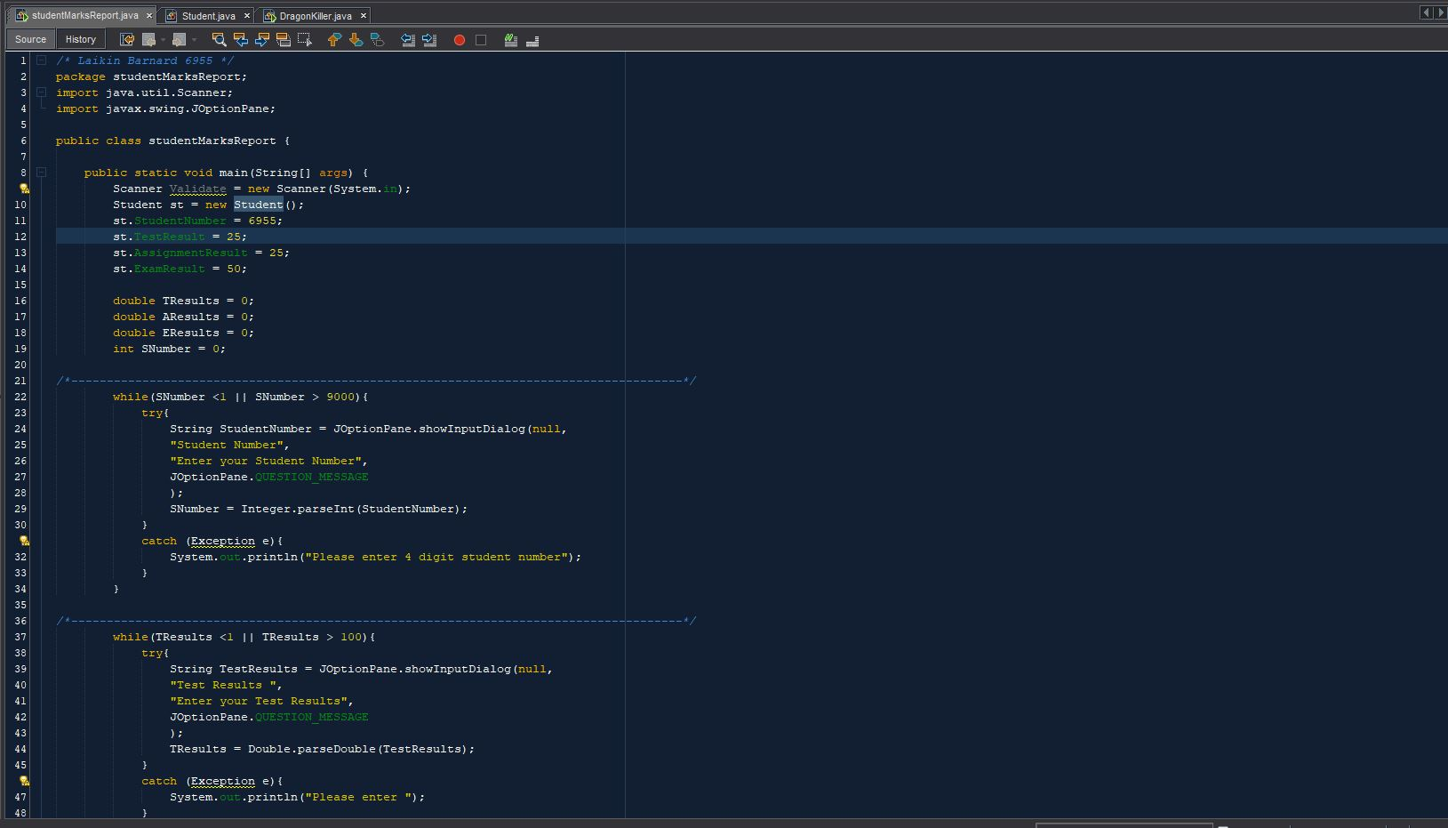

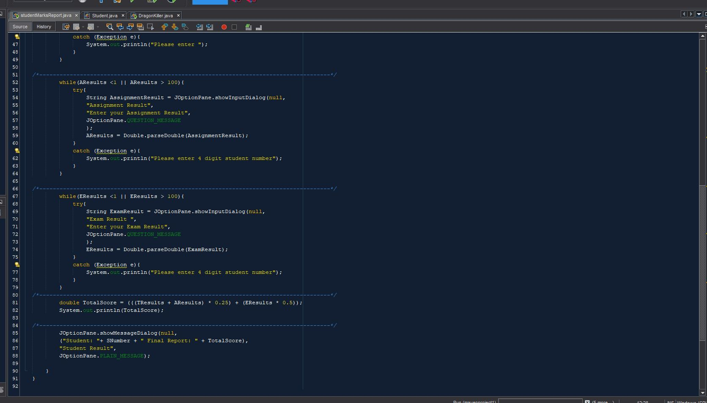

### Student

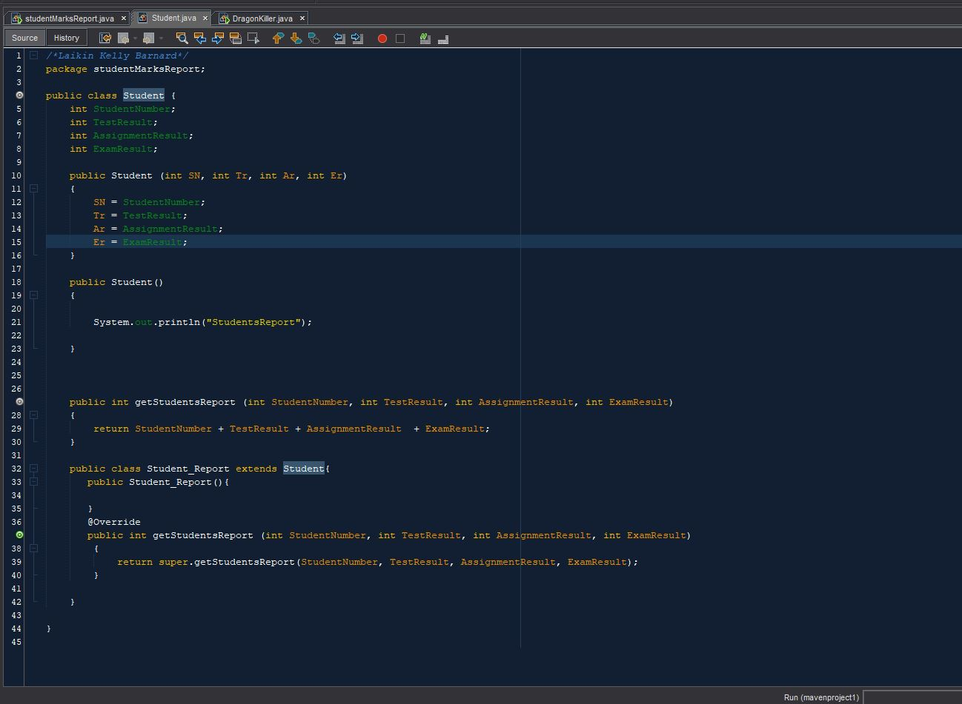

### Question 1 Results:

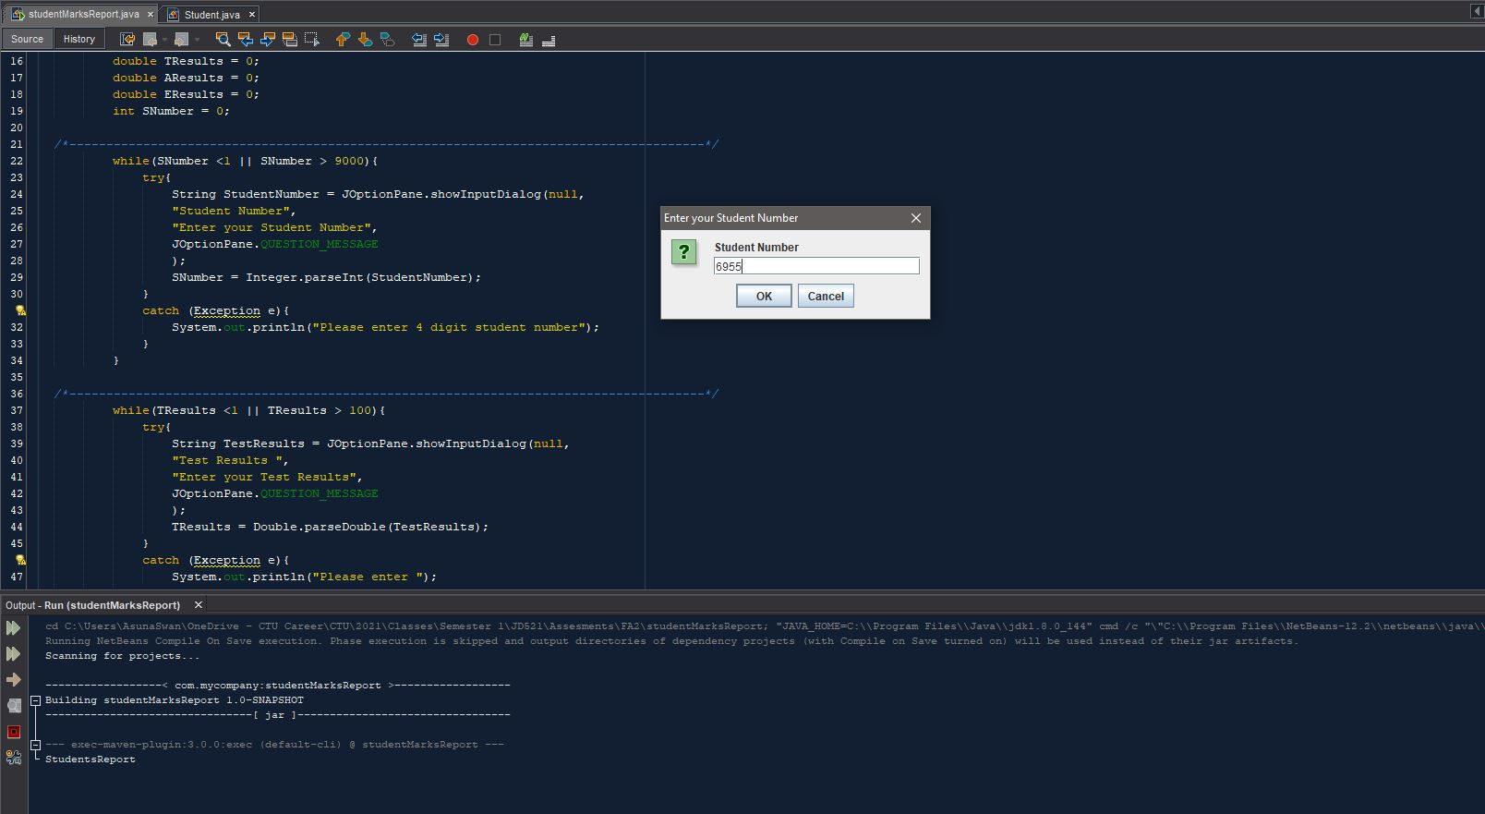

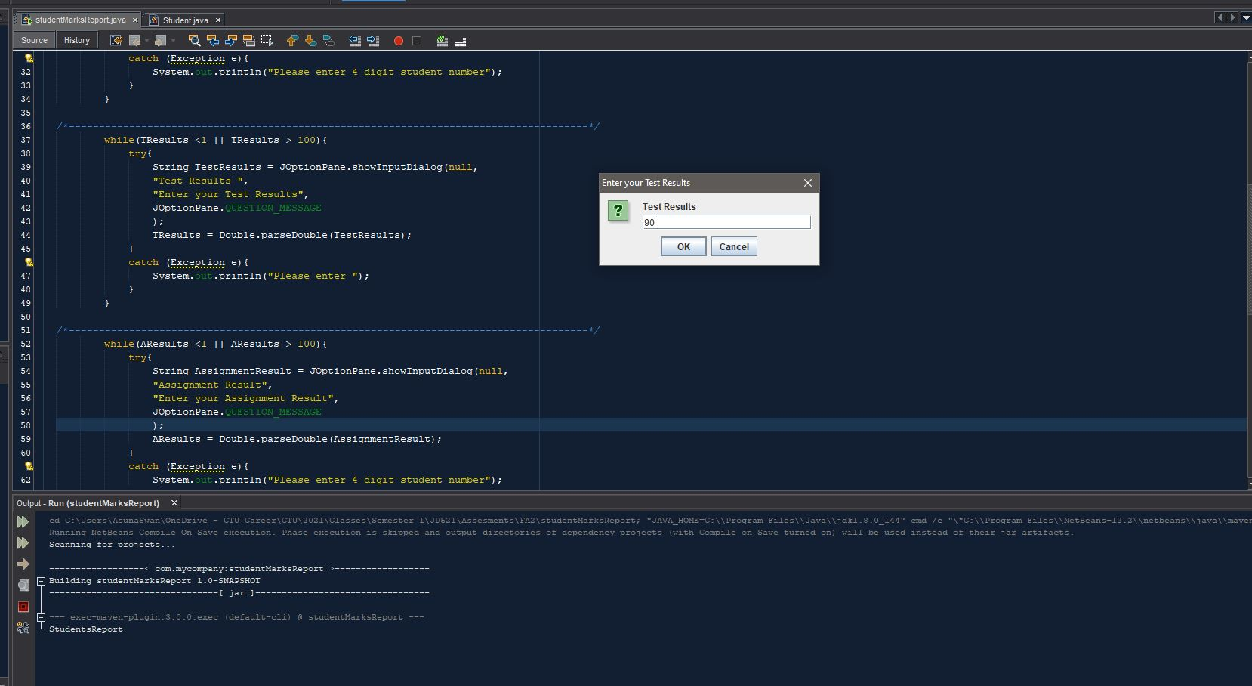

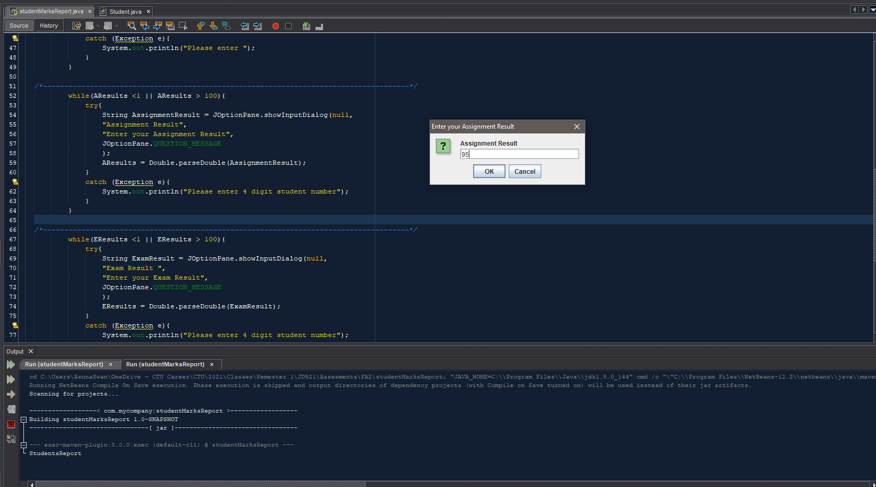

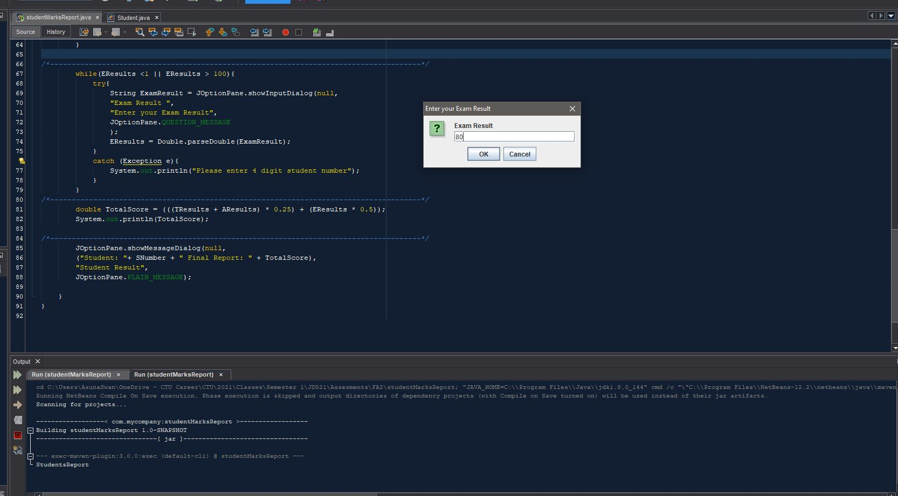

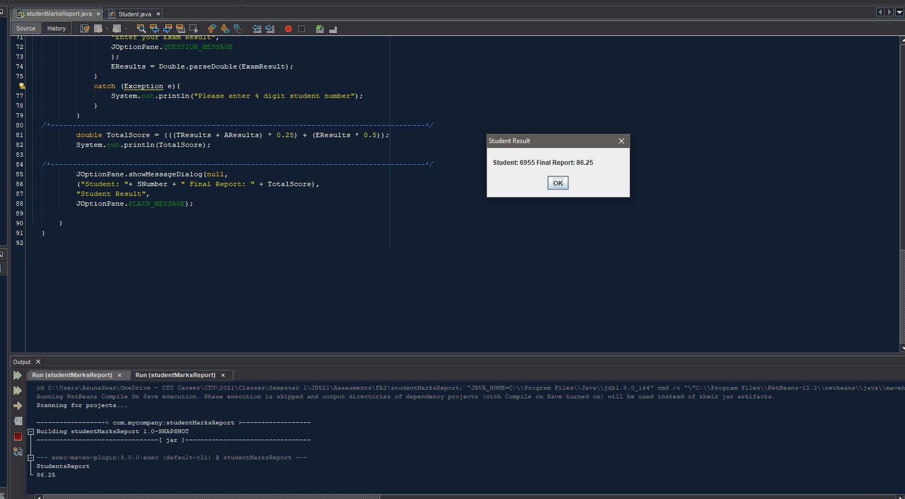

## Question 2

### DragonKiller

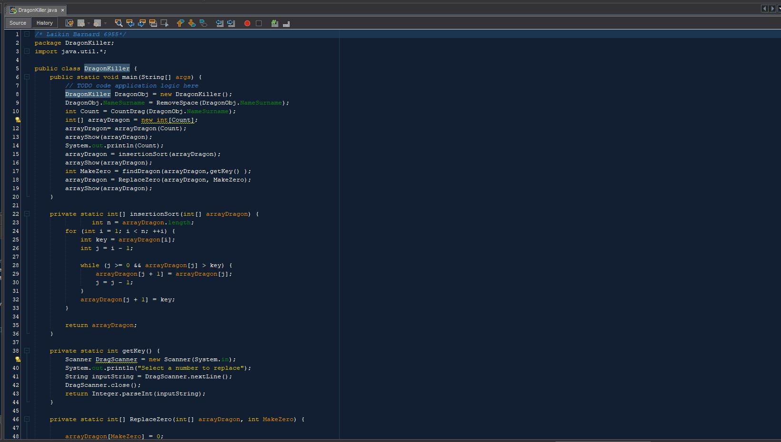

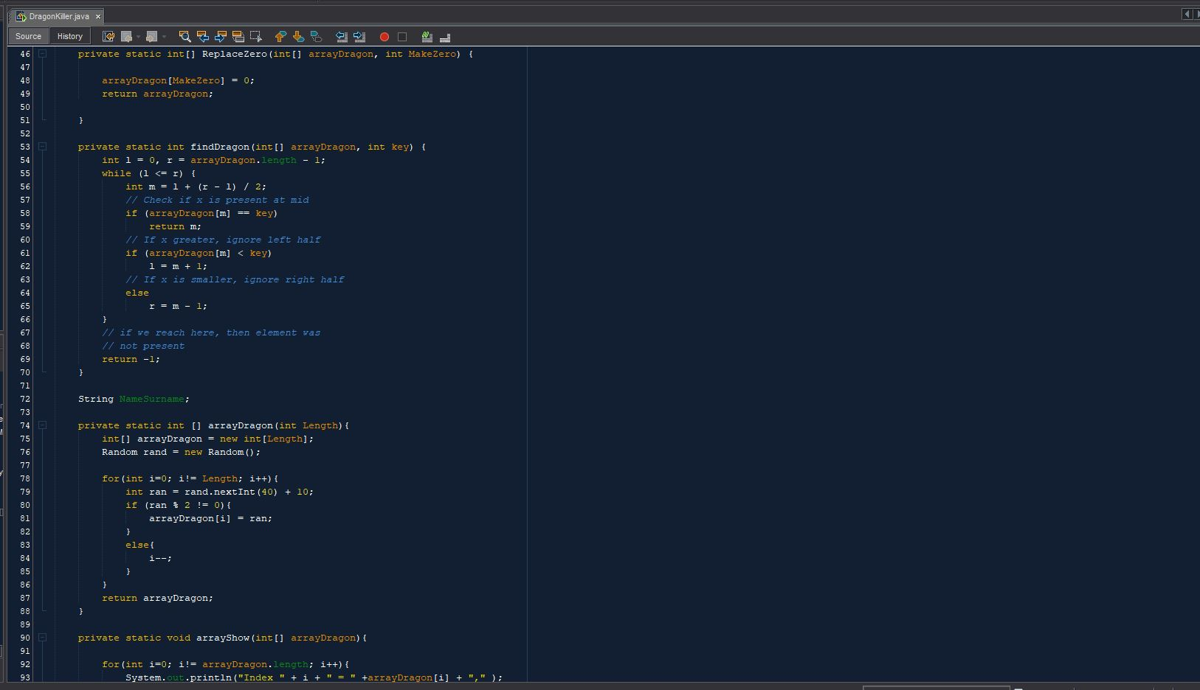

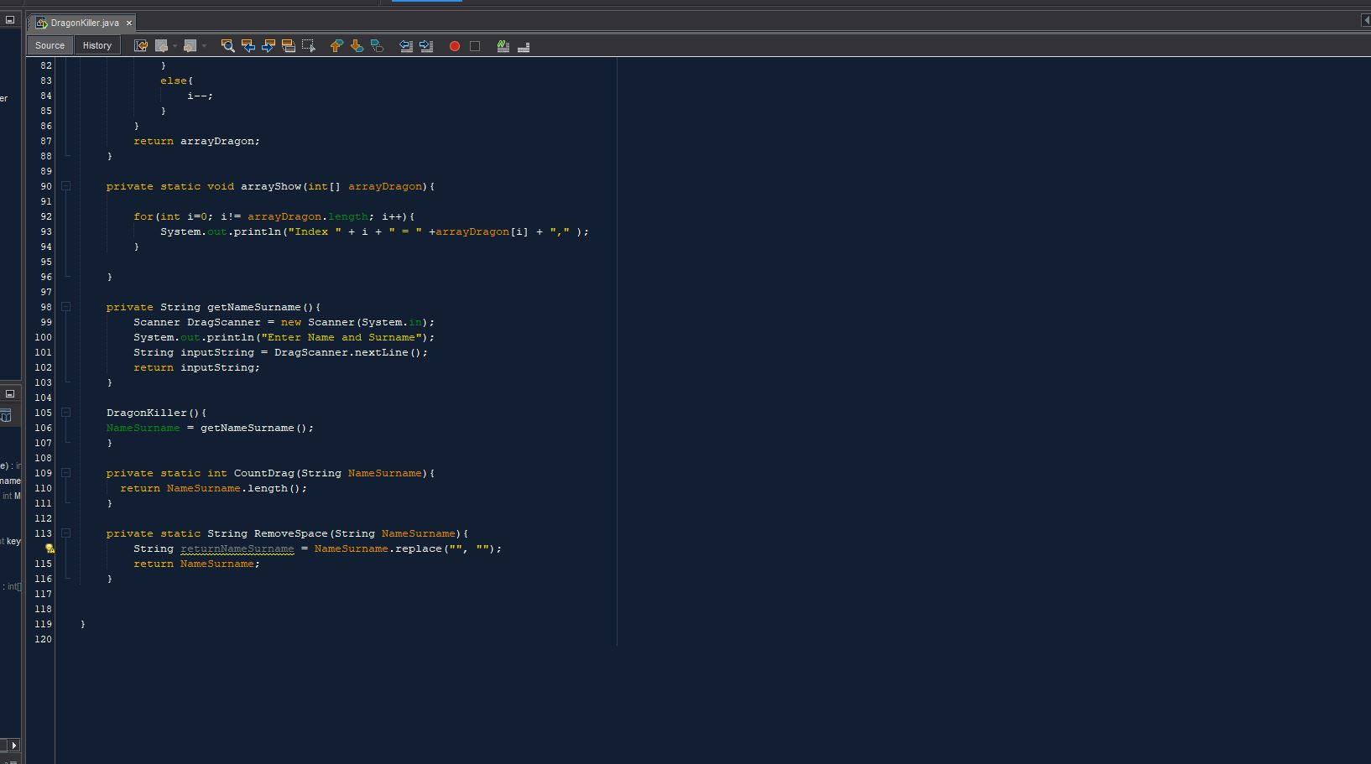

### Question 2 Results:

